Outline

RUSLE is an abbreviation for “Revisted Universal Soil Loss Equation”: it provides an estimation of the severity of erosion. This erosion prediction technology was applied in another framework (Beja, Tunisia). Within the framework of the Alpter project, we will test the method described in bottom:

A = R K L S C P

- A is the computed soil loss (tons/acre/year)
- R is the rainfall-runoff erosivity factor
- K is the soil erodiility factor
- L is the slope length factor
- S is the slope steepness factor
- C is the cover-management factor
- P is the supporting practices factor

Study Area- Béja, (Tunisia)
Data Used
- DEM (10 m)
- Soil Geographic database for Béja
- Aster and Spot images (10 m cell size)
- Rainfall Index Map
- Table of C factors in Agriculture reports by INA

Methodology

DEM
Slope
Slope Length
LS
Soil
Land Use
Rainfall Index Map
K factor
C factor
R factor
Erosion Map

R factor

The rainfall erosivity index which is equal to the mean annual erosivity value divided by 100: R = EI30/100.
(E) = total storm energy, the value is in hundreds of foot-ton per acre
(I30), = times the maximum 30-min intensity, the value is is in inches per hour (in/h).
if we don’t have the value (I30), another equation can be used:
(0,04830 P^{1,610} where P = mean/monthly rainfull
K-factor

- The K-factor was determined from the data downloaded with the soil types from the INA. The formula used to calculate the K value is:
- avec : M = (% limons + % sables) (100 - % argiles)
- b = code de structure des sols utilisé dans la classification des sols
- c = classe de perméabilité des profils

LS factor

The slope length factor and slope degree factors are typically combined together and defined as the topographic factor which is a function of both the slope and length of the land. The longer the slope length the greater the amount of cumulative runoff

$$\text{LS}=(\frac{x}{\text{22}\text{.}\text{13}})^{n}(\text{65}\text{.}\text{41}{\text{sin}}^{2}θ+4\text{.}\text{56}\text{sin}θ+0\text{.}\text{065})$$
Where
- x = slope length in feet;
- Theta = angle of slope; and
- n = 0.5 if the percent slope is 5 or more, 0.4 on slopes of 3.5 to 4.5 percent, 0.3 on slopes of 1 to 3 percent, and 0.2 on uniform gradients of less than 1 percent.

Other Equations of Calculating LS
$$\text{LS}=\sqrt{L/{\text{22}}\text{.}\text{13}}∗(0\text{.}\text{065}+0\text{.}\text{045}S+0\text{.}\text{0065}S^{2})$$
$$\text{LS}=(L/{\text{22}})∗(0\text{.}\text{43}+0\text{.}\text{30}S+0\text{.}\text{043}S^{2})/6\text{.}\text{574}$$
$$\text{LS}=(L/{\text{22}}\text{.}\text{13})^{n}∗(0\text{.}\text{065}+0\text{.}\text{045}S+0\text{.}\text{0065}S^{2})$$

C Factor

Land Use | C factor
Row Crops | 0.24
Pasture/hay | 0.05
Water/wet areas | 0.00
Urban, low density | 0.03
Urban, high density | 0.00
Forest | 0.009

P Factor
P is the conservation practice factor. Values are obtained from tables of the ratio of soil loss where contouring and contour strip-cropping are practiced to that where they are not. With no conservation measures, the value of P is 1.0.
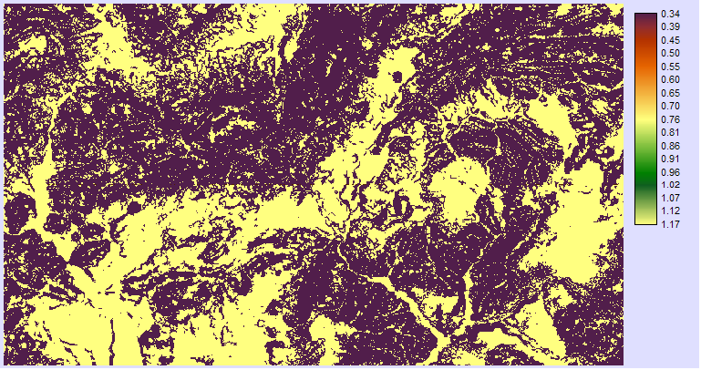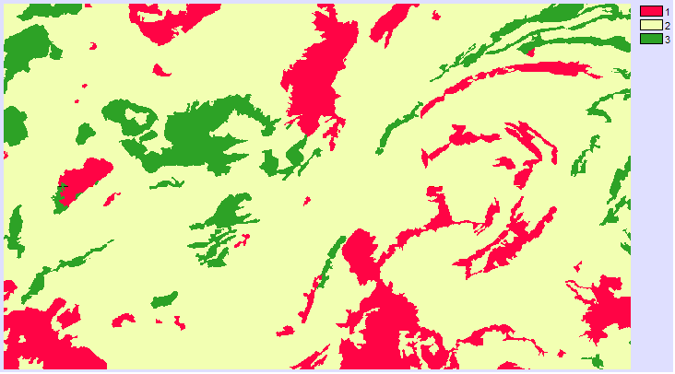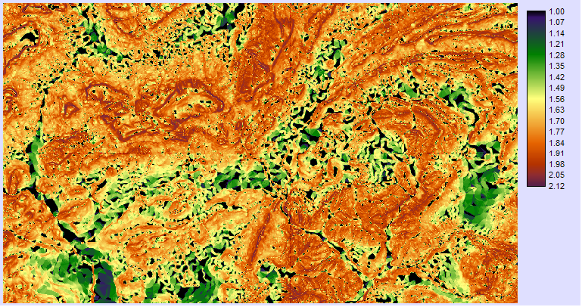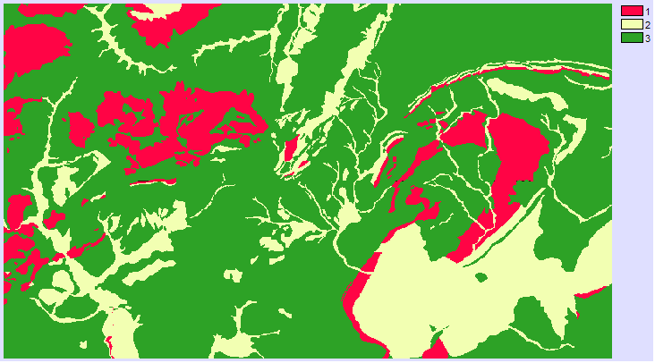
Results - Factors
f_ L
f_ S
f_C
f_ K

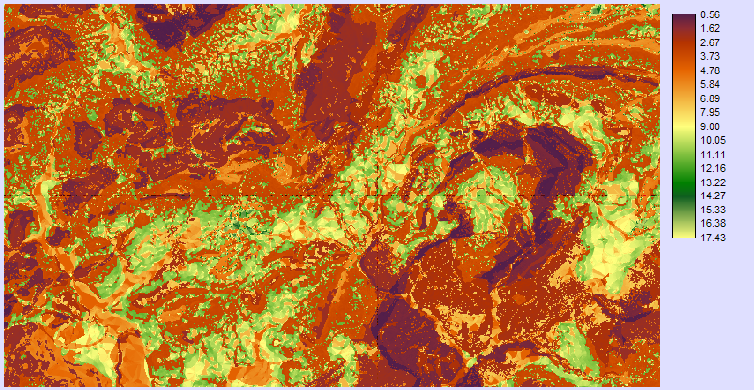
Erosion Map

The RUSLE was used to predict soil erosion in Béja (Tunisia) an its relatishionship with archaeological sites. As seen from the derived erosion map, most areas have value soil erosion which is between 5_ 10 tons/ha/yr. The areas of highest erosion occurred in the places where the slopes are the greatest and also the places where no management anti- erosif. Most the archaeological sites are located in the areas of lest erosion value (< 1t/ha/year).

