Study in progress of the site of Granile,
hamlet of the commune of Tende.
This site offers an example of slope strongly inclined and of high risk because of possible stone falls on the road Vintimille-Tende-Cuneo which borrows the gorges of Paganin. The old field terraces can remove at least part of this risk?
Other topics are interesting in the catchments area of the Valera stream: on these slopes marked by a great density in field terraces, linear cutting is slowed down, the grounds retained, and important are the vegetation and water resources (6 - Map).
Is it possible to carry all that to the credit of the field terraces now abandoned?
Climbing the path of the road (530m) to the hamlet of Granile (1100m) makes it possible to discover the outcrops and cornices of the sandstone of Trias, deeply incised out by Roya (Fig.1 and 4)
.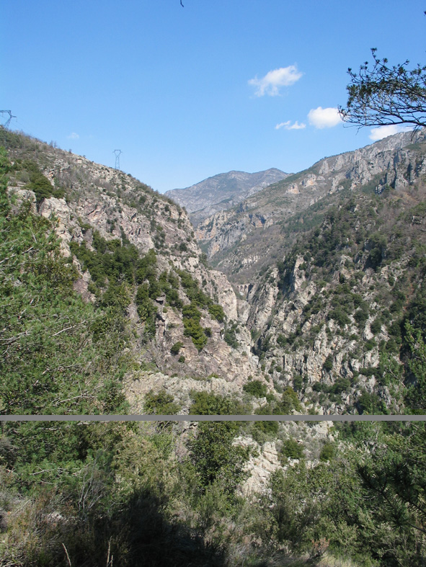
Fig.1. Tende, Roya valley, gorges of Paganin

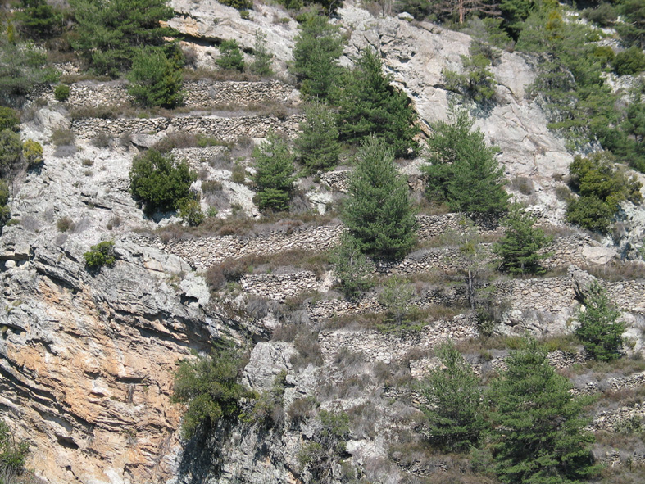
Fig.4. Vignon slope
The phenomenon of relaxation and the dip of the layers explain the high risk of stone falls, and the vulnerability of a primary distributer is large. But paths and terraces can stop a certain number of it (2, 3,4).
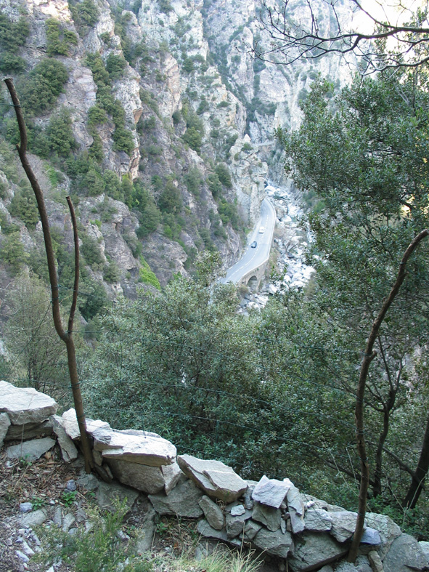
Fig.2. The path protects the road
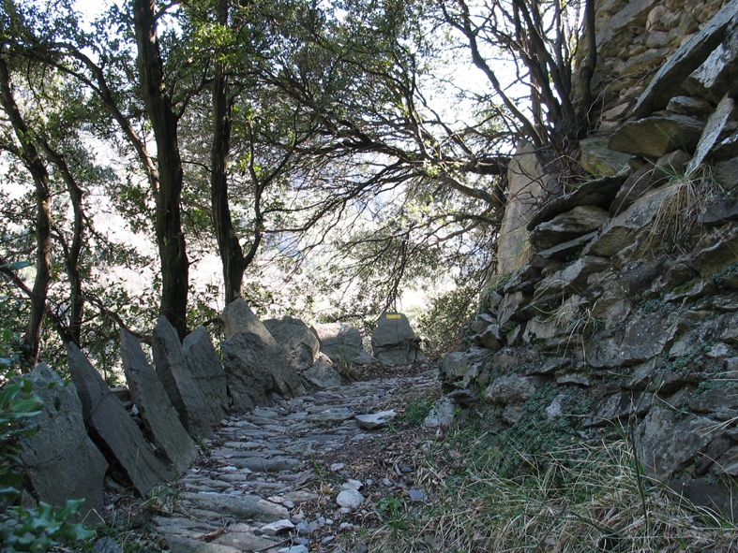
Fig.3. A well protected path
The comparison with sectors where the terraces miss upstream will make it possible to appreciate the importance of this role.
The slopes which dominate the road directly were cultivated in vine (4) while above 1000m are chestnuts, cereals and meadows irrigated on omnipresent terraces (5)
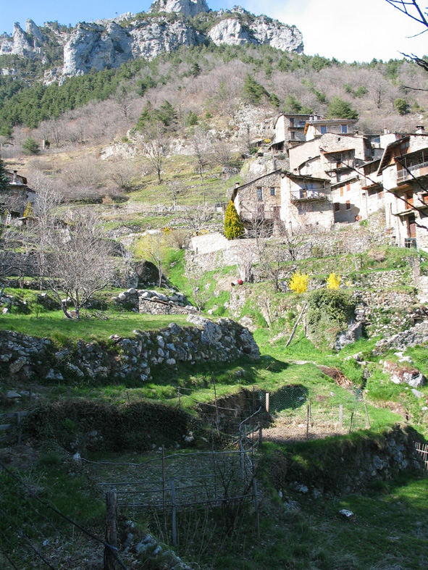.
Fig.5. Irrigated terraces near the hamlet of Granile
The great quality of this site results from many factors: exposure to South-east, abundance of water, sandy-argillaceous grounds, climatic staging allowing to pass from the vine to the subalpine lawn.
But the population disappeared, the maintenance of the slope ceased. Which recovery is possible to recover and develop such a favourable environment?
This study, under development, will have to propose some answers.
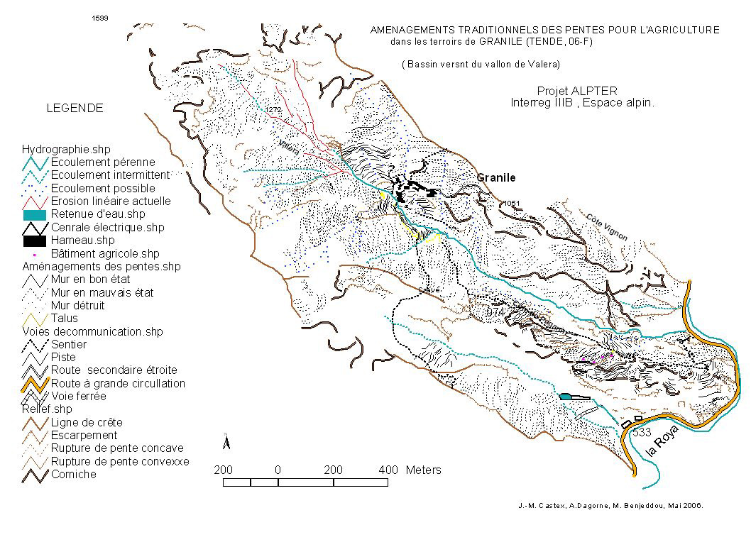
Fig.6. The map of Granile

______________
Some remarks: by Andrée Dagorne*, Vienna, 2006.
(* Maître de Coférences honoraire de Géographie
Université de Nice-Sophia-Antipolis, A.D.I.)

The alpine arc constitutes a unit georaphic group which has a certain unit but in the diversity of its regional territories belonging to various countries having a particular geography, economy and a demography with an own history. It is a territory essentially transborder where the borders often changed during the history.
The adjustments of the slopes, built by the men in reliefs of strong energy, were it in an economic context completely different from that from today: it was necessary to nourish the population and the horizontal planes were rare in an area of very broken relief. In addition, the rural countries, often insulated, had a relatively abundant and not very expensive labor (not of organized trade unions!). But to obtain plane surfaces was not conceived without a certain adaptation to the value of the slope; thus one finds walls of extremely different invoice, and elsewhere of simple "ribes "which cut the slopes. In all the cases, the Old ones, equipped already with a direction of the integrated management of these slopes, had set up very clever systems of management of torrential surface waters in particular in the southernmost Alps where hydrometeorological paroxysms are sometimes violent one. Without model available, the Old ones could manage the rural areas from the point of view of the constraints of sites (slope and exposure), according to grounds' by exploiting the complementarities of their potentialities and, in fine, managed the hydrological risks, at least as long as the human pressure did not exceed a certain threshold.
The appearance of industry to the XIX ème century involved some déprise demographic alpine zone (the Alps of the South mainly) except around the cities. Thereafter the variations decreased: tourism of snow attenuated contrasts the more so as one noticed then a progressive passage of the industrial society to that of a service society. The alpine cities, that they on the littoral or are far away, are always zones of attraction but, the price increasing of theground, one notes that and there a tendency to the reconquest of the close environments where landscape interests are strong. In parallel, the reduction of the working time leaves at "new country people" more times for maintenance of their environment even if the telecommuting did not always have the anticipated results.
In the Alpes-Maritimes, what to do the rural landscapes marked by the presence of terraces of various types? The answers are not single and it is necessary to consider activities seldom single and adapted to the structuring of the department in three great zones: the littoral, middle-country and high-country.
.To cultivate spaces having terraces? Yes but, is a single activity profitable? Not sure, because of the cost of labor which one always does not find. The floriculture which was formerly a gainful employment in the zones close to the sea, declines: arrive on the Market of National Interest the flowers of other countries obtained at lower cost (sometimes the economies come from the price of gas necessary for the greenhouses) that local flowers (case of the hills of Nice).Is in the high-country the chetnut cultivation profitable? Undoubtedly but there are few inhabitants… (Case of Granile).
. To cultivate and practice the breeding? To cultivate the olive-tree, to have a rural lodging, to process the agricultural produce (olive preserves, sale of oil, products derived like the tapenade), cheeses or jams of sweet chestnut (example of Escarène (back-country niçois) or of Fontan (high-country).
. To live in the rural areas in terraces? while conforming to the plan of occupation of the grounds obviously. Close to Nice, old terraces dedicated to the floriculture were recut and used for the construction of villas according to the principle of the reinforced earth (example of Nice Agora). In the close back-country niçois and the average country of the départementoù the properties (often heritages of family) are extended, raises the question of the maintenance of the walls, of the drainage canals, and that of the boards which should be cleared of undergrowth because the fire risk of forest exists! An original technique is proposed in Sigale (Means-country) where an inhabitant uses donkeys to clean the boards. Used jointly by an owner of rural lodging, the donkeys could interest the children with the other animals.
. A mixed use in High-Country with walks, the gathering of products like mushrooms, the sweet chestnuts, the archeological sites to visit, a rural lodging (Casterino).
. To maintain the rural landscape having adjustments of the slopes.
.. By fidelity with work of Old and for aesthetic reasons (still remains to know “beautiful rural landscape" what is called”)? Who will pay the note of maintenance? a rich patron? Difficult to find.
. .By concern of making safe the goods and the people? To manage the system of the flows of the torrential rivers is fundamental whatever the use of the terraces. To repair the breaches of the walls at the beginning of attack is less expensive than when the destruction is made. The structures of cut-slopes are still used to break the force of water but as today to block the torn off stones and to prevent as they will not fail on the roads located in against-low. One knows the weight of the budgets necessary to fit latticework on the walls of the roads of deep valleys (Rigaud) and the maintenance costs of the road axes.
What applies to the maintenance of the terraces related to agriculture is also worth for the actions which could be carried out after 1860 in the Alps of the South to limit the consecutive floods to too intense clearings: work of restoration of grounds in mountain with afforestation, setting places “gabions” in the beds of, the temporary canux rivers of flow, etc… and sometimes also installation of terraces political length of the curves of niveau.Une of maintenance which can be less expensive the community than that of a natural disaster (road blocked by mud flows, blocks, floods, etc… The case of View-point-Roquebillière is interesting by the globality of the problems arising (risuques of internal and external geodynamics).

